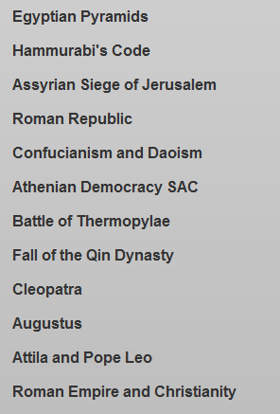

TOPICS AVAILABLE ON THE SHEG WEBSITE - https://sheg.stanford.edu/rlh

